Archaeological Research Conducted in Ngari Prefecture, Tibet Autonomous Region and
in the Amdo Region, Qinghai in 2007

A Report of Investigations Carried Out under a Program of Research Entitled “Defining the Paleolithic Presence on the Tibetan Plateau” Supported by the American Council on Learned Societies
& the Henry Luce Foundation



Mark S. Aldenderfer

John W. Olsen

Department of Anthropology
The University of Arizona

&

P. Jeffrey Brantingham

Department of Anthropology
University of California, Los Angeles

18 February 2008
Archaeological research conducted in Ngari Prefecture, Tibet Autonomous Region, July 2007

Introduction

Research during the 2007 season focused on the following research goals: 1) conducting reconnaissance level survey in three areas of the Sutlej (Langchen Khebab; 象泉河) river drainage in Ngari Prefecture, western Tibet Autonomous Region (西藏自治区阿里地区; Fig. 1) and 2) carrying out limited geological testing of terrace formations in these areas to determine strategies for their chronometric dating.

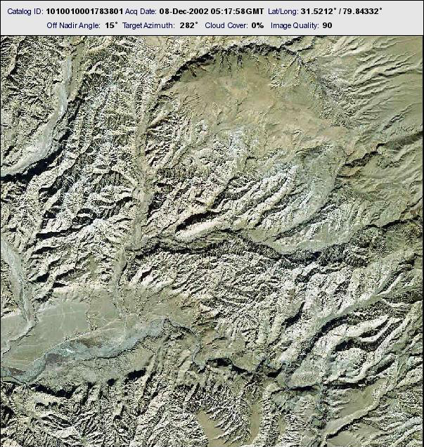

Figure 1. Ngari Prefecture, western Tibet Autonomous Region. Box outlines general location of project area.
The larger research goals of this project are to examine questions regarding the initial peopling of the Tibetan Plateau and to determine if multiple routes were used to gain access to it in the past. Until recently, most models of the process of peopling the Plateau assumed that the primary, perhaps sole, route of entry was from the north and northeast, and that this dated to the Paleolithic, perhaps as early as 30,000 years ago or more (Aldenderfer and Zhang 2004). However, recent archaeological research in far western Tibet has called this belief into question, and has suggested that multiple routes onto the Plateau at different times in prehistory may be plausible (Aldenderfer 2006).

One possible route onto the Plateau in the Tibetan far west is the Sutlej (Langchen Khebab, 象泉河) river channel and its terrace systems. The Sutlej descends into the Indian subcontinent from the Plateau via the Shipki La 锡布卡拉 (Tib. la = pass) in the Indian state of Himachal Pradesh (Fig. 2).

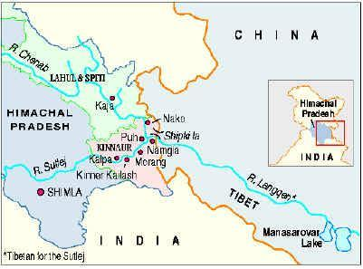

Figure 2. General location of Shipki La.

The Shipki La was a major trade route between India and Tibet for centuries [Hedin 1909 (1999)].

The research team consisted of three senior scientists from the U.S., two graduate students from the U.S., and one Chinese (Tibetan ethnicity) graduate student.

Lower Sutlej drainage study area

Reconnaissance level survey was conducted along the terrace systems on the south side of the Sutlej River near the modern town of Zada or Zhada (札达县, Fig. 3). The highest terraces in this area are older than 100 kya (thousand years before present), while younger terraces, some now destroyed by erosion, were probably formed during the Holocene (within the past 10 kya). Preliminary age estimates suggest that terraces 3-6 date to various periods within the Late Pleistocene and, therefore, should yield archaeological materials, if present, of Upper Paleolithic cultural affinities.

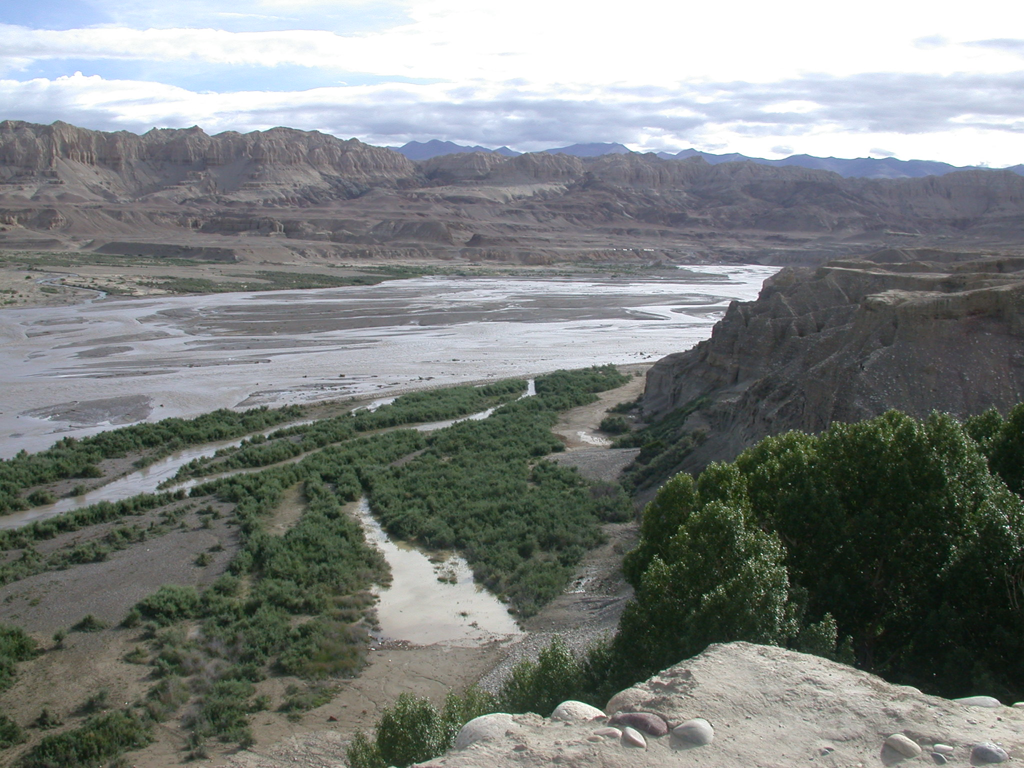

Figure 3. View of terrace systems on south side of Sutlej River near the modern town of Zada or Zhada (札达县).

Survey, then, was focused on the upper terraces, especially 4-6, although terrace 1 was examined as a rough check on the proposed dating scheme.

Because this was a reconnaissance level survey, strict maintenance of survey transects was not a priority. Instead, terrace margins were walked in a roughly parallel manner, and site and component locations were mapped with Trimble Geo XH high-resolution global positioning system (GPS) devices.

More than 150 archaeological sites of all time periods were discovered during the survey, and of these, 31 are likely to date to pre-Holocene, possibly Paleolithic cultural periods. Tool forms and reduction sequences in this region are poorly-defined, and since there are no excavated sites on the central Plateau with secure chronometric dating, only cross-dating of tool forms can be used to assess preliminary estimates of age.

Two distinct reduction strategies are observed: 1) a large flake/blade process, in which globular or irregularly-shaped nodules of local raw materials are struck to produce large flakes and/or large blade-like flakes (Fig. 4) and 2) a “splinter” technology, in which roughly rectangular nodules of local raw material are struck to create blade-like splinters of distinctive shape (Fig. 5).

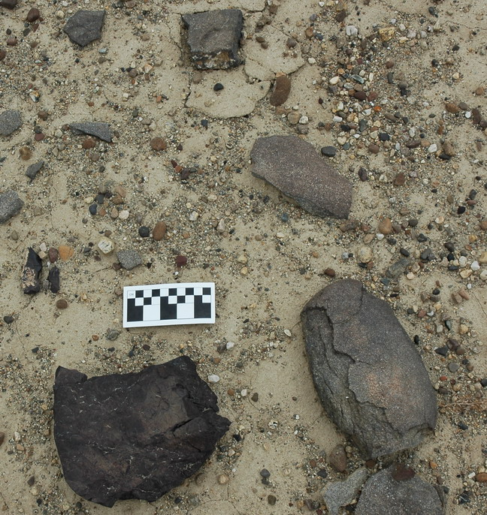

Figure 4. Large flake reduction debris in situ.

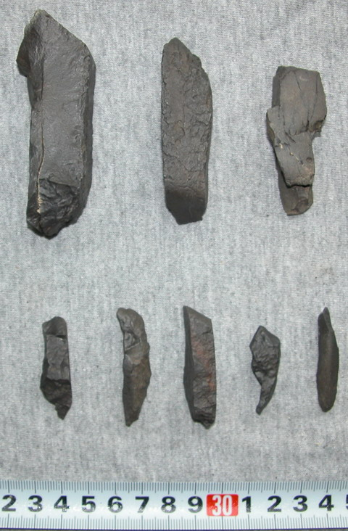

Figure 5. “Splinter” reduction debris.

Objects similar to the large flakes and flake/blades are relatively common further east on the Plateau (Aldenderfer and Zhang 2004), but similar reduction debris can also be found further to the west along the Sutlej drainage in India. These materials are thought in both instances to be of “Paleolithic” age. The splinter technology, in contrast, is not known from the central Tibetan Plateau.

One clearly diagnostic artifact discovered during survey was a Levallois-like flake found on Terrace 7 (the oldest terrace), see Fig. 6.

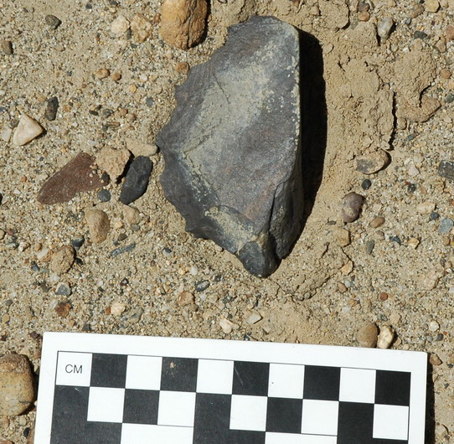

Figure 6. Levallois-like flake found in situ.

This technology is well-represented in South Asia, and is typically interpreted as “Middle Paleolithic” in age (James and Petraglia 2006). In India, such assemblages can be as early as 150 kya, although the nearest such assemblage to the study area, in the Dang-Deokhuri valley of central Nepal, is dated to ca. 30 kya (Corvinus 2002).

Of the 31 sites and components found in this portion of the study area, 18 are included in the flake/blade reduction category, and 13 exhibit predominantly splinter technology.

Upper Sutlej drainage study area

Survey was also conducted in the upper Sutlej drainage near the modern village of Kyunglung or Menshi (门士县), which is located some 80 km west of Zada. This area is relatively close to the headwaters of the Sutlej, which lie some 25 km to the east, and was chosen for examination because of the contrast it offers with the lower Sutlej in terms of geomorphology and terrace formation processes.

In this area, a total of 18 sites and components possibly dating to the Paleolithic were discovered. Of these, one contained a Levallois-like core or flake. Eleven of the components (including that with the Levallois-like flake) were characterized by the flake/blade reduction strategy, and nine reflected the splinter technology.

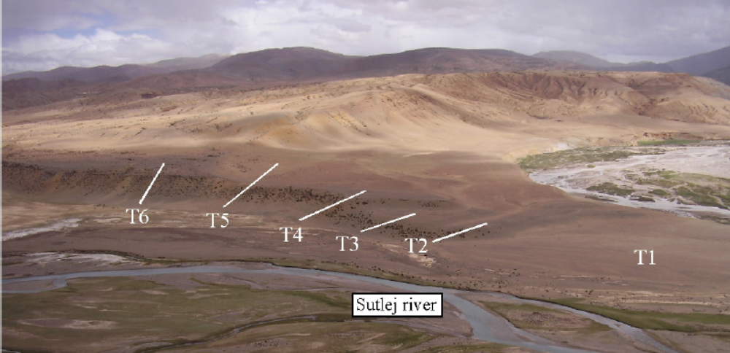

Figure 7. Terrace sequence on the upper Sutlej.

Conclusions

This aspect of our research has demonstrated that there was substantial aceramic (presumably preceramic) lithic utilization of the terraces of the Sutlej River systems in far western Tibet. Although secure chronometric data are still elusive, the presence of Levallois-like materials on the Plateau similar to those reported from Nepal and India suggest that a late Paleolithic migration onto the Plateau is plausible. Should the dates of the Nepali assemblages be valid for understanding the Plateau, we can assign an approximate age to the Levallois-like specimens of ca. 30 kya. This date may be interpreted as a terminus ante quem (minimum age).

Future expeditions will conduct further surveys as well as seek out sites in the drainage that have stratigraphic integrity and the potential of chronometric dating so as to address the question of this potential early migration in a systematic and conclusive manner.

Paleolithic investigations conducted in northern Tibet (Qinghai/Amdo), June-July, 2007

Introduction

Our work in the Amdo region (安多地区) of the northern Qinghai-Tibet Plateau (青藏高原) focused on survey for and test excavation of archaeological sites in central and southern Qinghai Province (青海省).

A team of eight researchers conducted fieldwork during the months of June and July, 2007. The team included three senior scientists from the U.S., one senior scientist from China, two U.S. Ph.D. students and two Chinese Ph.D. students. Work involved investigation of several geological localities for our continued paleoclimatological work in the region, archaeological survey for new sites and small-scale excavation of several newly identified localities.

Qinghai Lake Basin Paleoclimatic Research

As a follow-up to work conducted in 2006, we revisited five geological localities at Qinghai Hu (青海湖, Qinghai Lake or Koko Nor) that have proven critical in documenting the late Pleistocene and Holocene history of the lake. We are interested in the degree to which human occupation of the Qinghai Lake Basin is correlated with environmental and climatic fluctuations; hence we have conducted a dating program at each of the five geological localities and returned in 2007 to do detailed sedimentological descriptions and to complete section drawings. This work has been accepted for publication in Quaternary Research.

Qinghai Lake Basin Archaeological Research

In 2007 we returned to an archaeological site (first identified in 2006) exposed in a gravel pit associated with the Hudong Yangchang Dam. The site consisted of a circular hearth or fire-pit with an associated scatter of stone tools. The feature was ¹⁴C dated to ~13,000 calendar years before present and our 2007 visit was focused on increasing the size of the stone tool sample. The Dam Site is the third locality in the Qinghai Lake Basin to be placed in the time range between 13-15,000 calendar years ago.

We identified a new archaeological site at the canyon mouth near the settlement of “151” (一五一). This is a large, heavily organic midden containing abundant bone, some coarse ceramics, and microblades. In appearance and material content, the “151” site is similar to Jiangxigou 2 (江西沟 2; located ~15 km to the east), which is dated to between 6-9,000 calendar years ago. Future work in the area may involve excavations at “151.”

Archaeological Reconnaissance in the Gonghe Basin

The Gonghe Basin (共和盆地) lies south of the Qinghai Nanshan (青海南山) Mountains and represents one possible route that humans may have traversed onto the Tibetan Plateau. There is a reasonably well-known mid-Holocene Neolithic complex, the so-called Zongri Culture (总日文化), already identified in the Gonghe Basin. We surveyed several of the south-flowing drainages out of the Qinghai Nanshan, all tributaries of the Huang He (黄河 Yellow River). A stratified archaeological site was identified and excavated in the Gouhou (沟后) drainage. The site consists of an intact loess stack on the first terrace of the Gouhou with two stratified hearths containing a small amount of bone and numerous microblades. Samples were collected for radiocarbon dating and will be processed this fall. In general, these sites seem to record the crucial Paleolithic to Neolithic transition. Our future research strategy here will attempt to illuminate farmer/forager interactions and the development of pastoralism and agro-pastoralism in the region.

We also surveyed for prehistoric sites in the region surrounding the Lin Xia (林峡Lin Gorge). The geological setting in this area, however, is poor for archaeological site preservation and results were not encouraging.

Investigations in the Xiadawu & Donggi Cona Regions

Our work in higher elevation areas (above 4000 m asl) concentrated on terraces of the Xiadawu River (下达吴河) and beaches of Lake Donggi Cona. Previous work conducted by tectonic geologists from the Freie Universitaet Berlin at Xiadawu yielded dated charcoal associated with what appeared to be a hearth buried at a contact between alluvial gravels and loess (Liu et al. 2005). The dates (clustering around 11,000 calendar years ago) could potentially represent one of the earliest securely dated archaeological sites on the northern Tibetan Plateau (Hou and Liu 2004; Xie 2002). This year we confirmed not only that the dated Xiadawu material derives from a true anthropogenic hearth, but also that there are at least five large archaeological localities in the vicinity. One of these is a stratified site with hearths buried at two different depths. The abundant stone tools at all of these localities were produced through specialized bladelet and microblade technologies resembling materials from the Chang Thang region (可可西里地区) of the northern central Plateau. The fact that some of the Xiadawu localities are stratified rather than merely surface aggregates or deflational lags is important in and of itself. Further investigations of these Xiadawu sites may allow us to identify multiple chronologically discrete occupations extending back to the period immediately preceding the close of the Pleistocene (Yuan et al. 2007).

Donggi Cona is a large tectonic freshwater lake at an elevation of approximately 4100 m asl that drains to the north (toward Xiangride 香日德). At least one +10-meter beach documents higher lake stands in the basin at some presently unknown earlier time. Our 2007 survey of this lake basin identified two surface localities on the +10-meter strandline containing bladelet and microblade technologies similar to those from Xiadawu. As it appears that Donggi Cona is periodically dammed by floodwater events where it discharges, it is possible that individual shorelines may have been occupied several times over long periods. We found multiple archaeological sites on various shorelines and initially thought they might be of assistance in dating lake level fluctuation. However, if the lake’s level is not climate controlled, the presence of these cultural remains may not be of great utility in understanding its complex history. Future work on the Donggi Cona shorelines will include the collection of multiple ostracod and/or pollen samples from laminated deeper water sediments and/or Optically Stimulated Luminescence (OSL) samples from the sandy shoreline to help resolve these difficult chronometric problems (e.g., Wang et al. 2004).

Excavations in Tu Jiu Rockshelter

Originally tested in 2005, our team returned to Tu Jiu Rockshelter (秃鹫小洞), west of Dulan (杜兰县), in 2007 and extended our trial excavation down to a depth of 3.3 meters below the present ground surface. We identified a hearth below one previously dated at roughly 3,900 radiocarbon years ago and encountered a layer of sheep dung underlying this feature. Should these fecal pellet samples yield dates of 4-5,000 calendar years old or older, we will attempt to extract DNA and define what may be some of the earliest evidence for sheep domestication in China.

References Cited

Aldenderfer, M.
2006 Modeling plateau peoples: the early human use of the world's high plateaux. World Archaeology.38(3): 357-370.

Aldenderfer, M. and Y. Zhang
2004 The prehistory of the Tibetan Plateau to the 7th C. AD: Perspectives and research from China and the West since 1950. Journal of World Prehistory 18(1): 1-55.

Corvinus, C.
2002 Arjun 3--a Middle Paleolithic site in the Deokuri Valley, Nepal. Man and Environment 27: 31-44.

Hedin, S.
1909 (1999) Trans Himalayas. Asian Educational Services, Delhi.

Hou, G., and Liu, F.
2004 Pre-history and climate change of eastern Qinghai. Acta Geographica Sinica 59: 841-846.

James, H. and M. Petraglia
2006 Modern human origins and the evolution of behavior in the later Pleistocene record of South Asia. Current Anthropology 46: S3-S27.

Liu, F., Hou, G., Zhang, Y., Zhang, Z., Xu, C., Zhou, Q., and Zhang, H.
2005 The impact of abrupt climate change in mid-Holocene on the prehistoric culture in northeast Qinghai. Acta Geographica Sinica 60: 733-741.

Wang, J., and Xiong, W.
2004 Relationship between the ancients’ migration and climate change in the later period of late Pleistocene in Tibet. Acta Geographica Sinica 59: 174-182.

Xie, D.
2002 甘肃青海省史前考古学 Gansu Qinghai Sheng Shiqian Kaoguxüe (Prehistoric Archaeology of Gansu and Qinghai Provinces). Cultural Relics Press. Beijing.

Yuan, B., Huang, W., and D. Zhang
2007 New evidence for human occupation of the northern Tibetan Plateau, China during the Late Pleistocene. Chinese Science Bulletin 52(19): 2675-2679.

